Week 2 GAME OF HEARTS

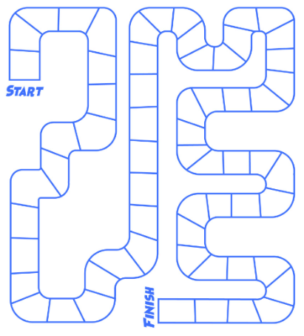

SUPPLIES
- Dice [Find your dice!]
- Gameboard
- Game Cards
- 1 Heart Gaming Piece [You may decide to give this away to someone special after you play the game!]

How to Play:
Place game cards on the table in a stack, don’t touch until the game starts. Roll an odd number move ahead 2 spaces. Roll an even number go back 1 space. If you land on a heart collect a matching card from the stack. The player to reach the finish line with the most matching heart pairs, WINS!

Resource
https://amazinggameroom.com
DID YOU KNOW? The longest game of monopoly went for 70 days!!

