WEEK 1
Butterfly, Autumn, and a Tree

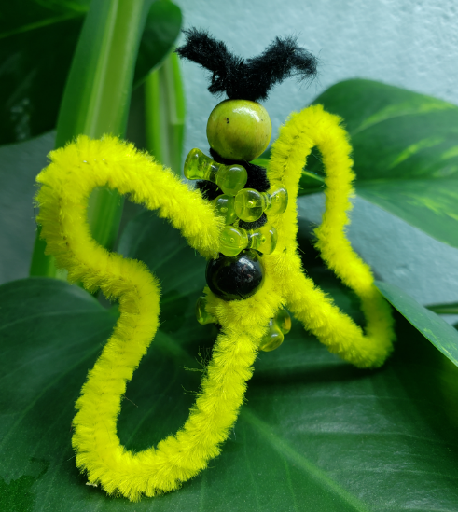

SUPPLIES
- 2 Pipe cleaners
- 2 round wooden beads
- 8 fun shaped beads

DIRECTIONS
- Bend one of the pipe cleaners in half.
- Next, add a fun shaped bead to one side and then one fun shaped bead to the other side of the pipe cleaner. Do this one more time.
- Add a round wooden bead and repeat two more times.
- Add one final bead at the top, snip or leave the antennas long or short.
- Take the 2nd pipe cleaner and twist in the middle and mold into the shape of butterfly wings.

Question: Is it true that monarch butterflies travel all the way to Mexico and stay in a tree? If so, what is the name of the tree? Is it an oak, maple, or fir tree?

Come to programming and find out this answer, or better yet, you tell us the answer!

