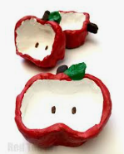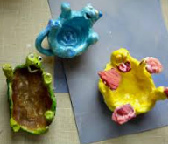

Activity #1 Apple or Animal Scented Cinnamon Pinch Pots!

Supplies
- 1/2 cup flour
- 1/4 cup of warm water
- 1/4 cup table salt
- Cinnamon
- Paint

DIRECTIONS
- Step1 Mix 3 ingredients together
- Step 2 Sprinkle surface with flour, next flatten your dough, now it is time to create your pinch pot apple!
- Step 3 Microwave in 10 second bursts checking regularly. Super Important!

Add paint if you wish!! Use your fingers, it makes it much more fun! Get those creative juices flowing!

