Activity #2 Moon ART!

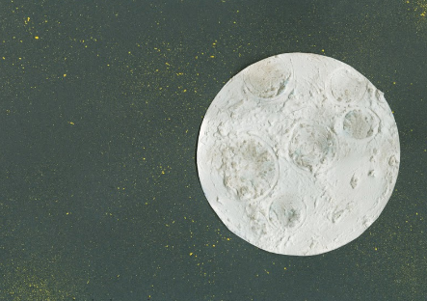

Supplies
- Flour [This will create a paste for the moon]
- White paint
- Small glass (not provided) [Used for stamping moon craters]
- Small paper plate [this will become your moon]
- Wadded up paper towel [Used to dab white paint onto your black paper]
- Black or blue construction paper

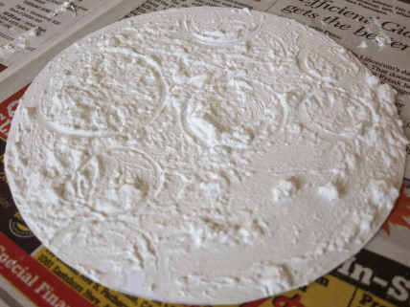
Directions: Lightly tap white paint with paper towel onto black paper to make stars. Mix the white paint, flour and water (if needed) until you make a paste. Use your fingers to spread onto the paper plate. Set aside to dry. To finish, glue your finished moon onto the black or blue paper.
Source: https://www.cindyderosier.com/2014/07/the-cursive-project-moon.html

