Activity #2 Kandinsky Concentric Circle Art

Are you ready to make 3-D Art like a real artist does, check out the Kandinsky art - abstract art the Kandinsky Concentric circles! Let’s get started!

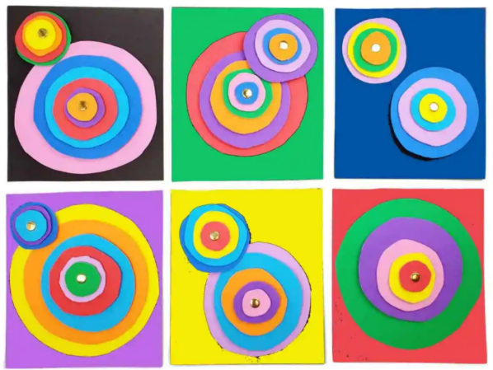

Supplies
- Assorted textures of card stock and colored paper
- Fastener

Directions
Cut your textured paper into different sizes of circles. Use your drinking glasses or cups as an object to trace around. Suggested circles per stack is 5. Stack the circles than connect through the middle with the fastener.

Source https://thecraftyclassroom.com/crafts/famous-artist-crafts-for-kids/wassily-kandinsky-art-project-for-kids/

