BEAN TIBERIAN

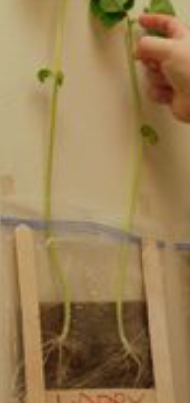

SUPPLIES
- A broad bean seed
- Ziplock Bag
- Soil
- Water

INSTRUCTIONS
Add soil to the bottom of your ziplock bag.
Splash a small amount of water into the plastic bag.
Place the bean seed into the soil.
The bean should start to grow roots after a few days, this is called germination. Wow, this is super cool stuff!

Time to be an investigator! “How do you think a bean can grow inside a plastic bag?”
This germination investigation is very simple but fascinating. Did you know you can grow a bean in a plastic bag with just a little water? Germination is the sprouting of a seedling from a seed.

What does a seed need to help them grow, just 3 little helpers…
- Water – seeds need water for germination to occur. When a seed drinks or absorbs water it starts to swell up, the outer coat of the seed cracks and roots start to grow through. This is like magic!
- Oxygen – oxygen is needed for a plant to grow. Seeds buried too deeply in the soil won’t grow. Be careful not to go too deep when planting in the soil.
- Temperature – temperature can be important, not too hot and not too cold, just right!

